The ISPRS Geospatial Week 2023 - Conference Report

I had the privilege of attending The ISPRS Geospatial Week 2023, held at Cairo. The conference brought together experts, researchers, and professionals from various disciplines to discuss and explore the latest advancements in geospatial technologies and applications. I am immensely grateful for the opportunity to participate in this prestigious event, made possible by the generous support of [The ISPRS Foundation's Travel Grant.](%5bhttps:/www.isprs.org/foundation/uploads/news/TIF_TRAVEL_GRANT_AWARDEES_FOR_GSW2023-revised.pdf)

During the conference, I actively engaged in various activities, including attending insightful keynote speeches, participating in workshops, and networking with fellow researchers. As a recipient of The ISPRS Foundation's Travel Grant, I was able to present my research findings in an oral presentation entitled "Spatio-Temporal Analysis of Urban Economic Resilience During COVID-19 with Multilayer Complex Networks." This study aimed to analyze the impact of the COVID-19 pandemic on restaurant closures in China and the United States, utilizing a multilayer complex network percolation method for simulation. The presentation provided an opportunity to share my research methodologies, findings, and conclusions with the audience, leading to fruitful discussions and valuable feedback.

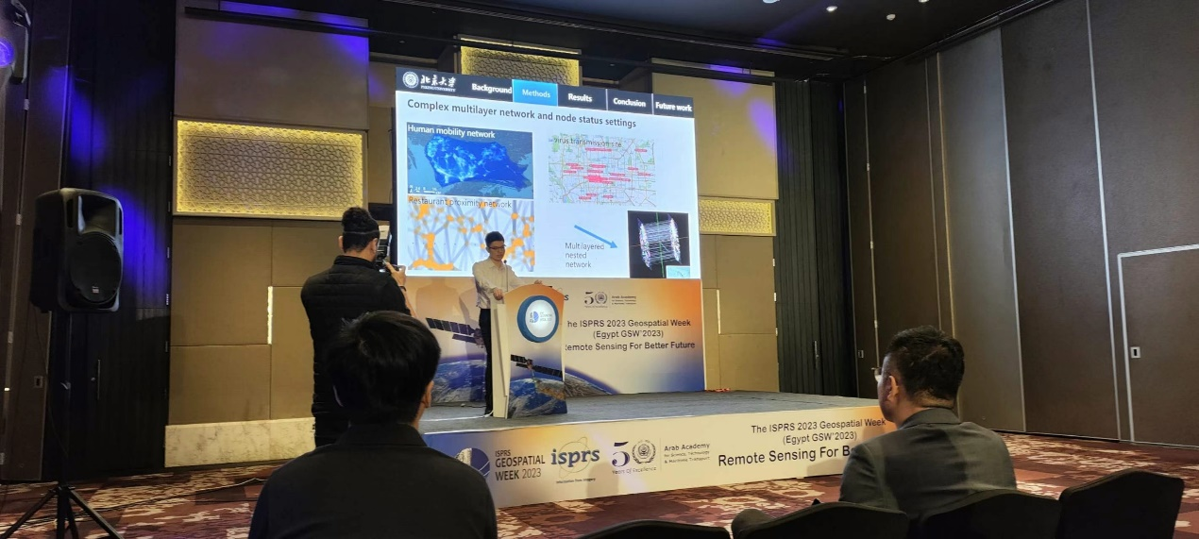

The conference provided a platform for exchanging knowledge and experiences in the field of geospatial sciences. I attended several sessions and sub-forums that aligned with my research interests, including the "GeoHB 2023: Geo-Spatial Computing for Understanding Human Behaviours" sub-forum. This sub-forum explored the complexities of urban spaces and the utilization of spatial big data and advanced computing technologies to better understand human behavior and address urban challenges. The discussions and presentations delivered by experts in the field significantly expanded my understanding of the subject matter and inspired new research directions.

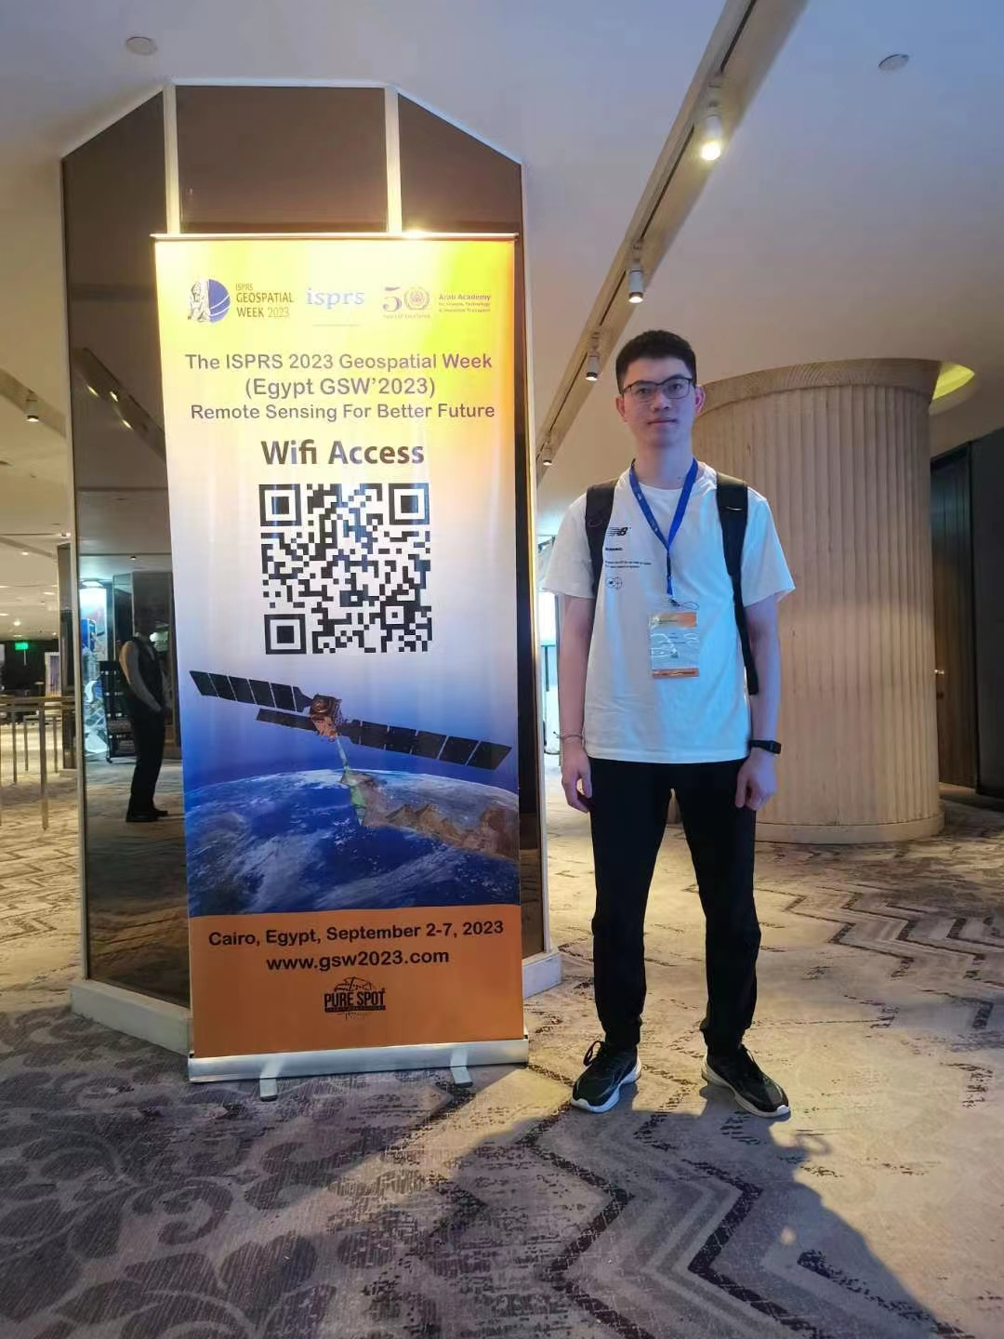

One of the most valuable aspects of the conference was the opportunity to network with esteemed professionals and researchers from around the world. I had the privilege of engaging in meaningful conversations and establishing connections with fellow participants who shared similar research interests. These interactions opened doors for potential collaborations and future research partnerships, fostering an environment of knowledge exchange and growth.

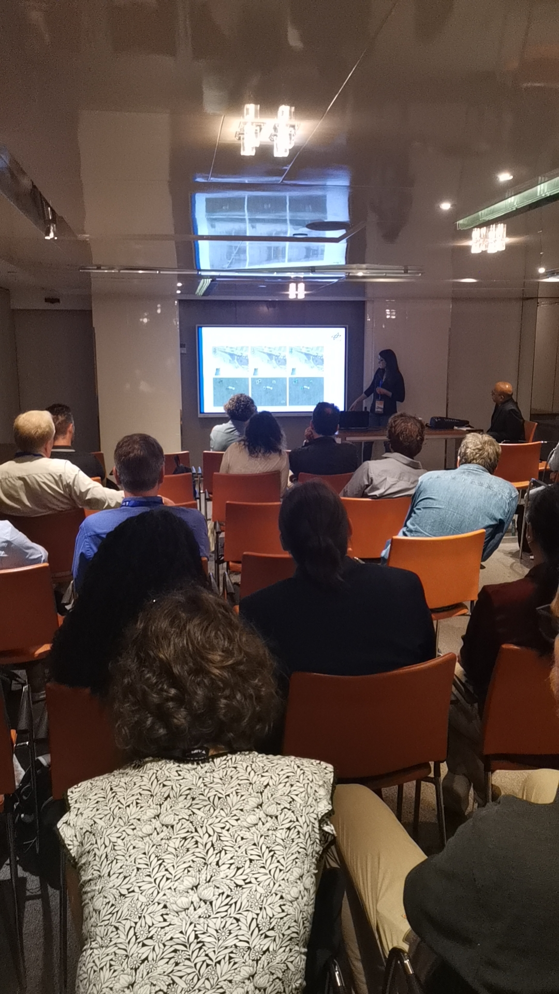

I would like to express my sincere gratitude to The ISPRS Foundation for awarding me the Travel Grant, which made my participation in The ISPRS Geospatial Week 2023 possible. As a master's student with limited financial resources, this grant has played a crucial role in supporting my academic and professional development. The financial assistance provided through the grant covered my travel expenses, conference registration fees, and accommodation, relieving the financial burden associated with attending such a significant event. I am truly appreciative of The ISPRS Foundation's commitment to supporting young researchers and their contributions to the geospatial sciences.

Attending The ISPRS Geospatial Week 2023 was a transformative experience for me as a researcher. The conference provided a platform to showcase my work, learn from experts in the field, and establish connections with like-minded individuals. I am grateful to The ISPRS Foundation for the Travel Grant that supported my participation in this event, as it has played a crucial role in my academic and professional development. I extend my sincere appreciation to the organizers, presenters, and attendees for making this conference a resounding success.

I look forward to implementing the knowledge gained from this conference into my research and contributing to the advancement of the geospatial sciences.